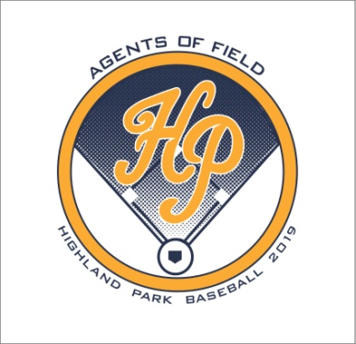
Meet The Scots
And In-N-Out Burger Cookout
Friday, February 1, 2019
5:00-7:30pm
Scotland Yard
Please join us for the In-N-Out Burger Cookout during Meet the Scots benefiting the Highland Park Baseball program. In-N-Out will be serving a Burger Basket with a delicious Burger, chips and a drink.
Entrance to the event is FREE! The first 75 elementary and middle school kids will get a free T-shirt.
- 5:00-7:00pm In-N-Out Burger Cookout (tickets required)
- 5:30-6:00pm Meet the HP Scots Varsity players – get autographs and pictures
- 6:00pm Highland Belles Performance
- 6:15-6:30pm Team Player Introductions:
Scots Baseball Club
JV Gold
JV Blue
Varsity
- 6:30-7:30pm JV Blue and Varsity Baseball Practice
All funds raised help meet our operating costs. Enclosed you will find an order form for the Burger Basket tickets and underwriting forms. To receive recognition in the Meet the Scots Event program, kindly return by Monday, January 28th.
We appreciate your continued support and thank you for your generous donation to the Highland Park Baseball Program!
GO SCOTS!!!

